**NOAA Ship THOMAS JEFFERSON Procedure Document**

Procedure:

**Post Process GAMS**

Creation Date:

8/27/2020

Revision Date:

Software used:

POSPac

Procedure Number:

**TBD**

Approved:

**TBD**

# Overview and Scope

How to post process GAMS.

# Procedure Inputs and Outputs

## Inputs:

.000

## Outputs:

# Procedure

Process into POSPac as you normally would. Before you run the GNSS- Inertial Processor, go to Project Settings. Under the GNSS-Inertial Processor folder, select GAMS. Set the Standard Deviation to 5cm and click okay.

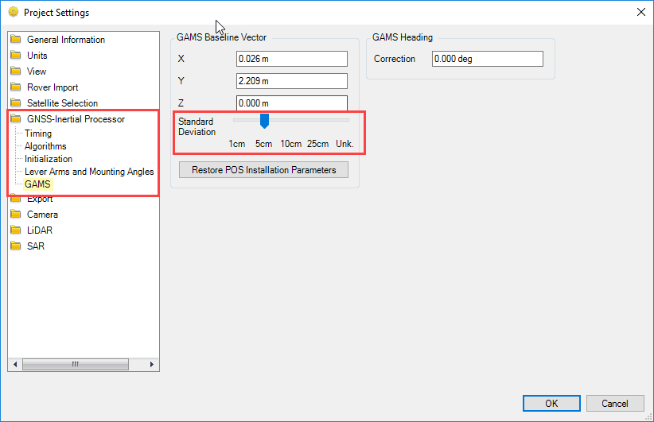

Run the GNSS-Inertial Processor for IN-Fusion PP-RTX. After you run the GNSS-Inertial Processor select the reports tab at the top of the program and select display plots.

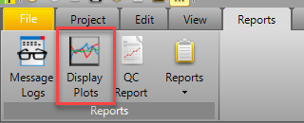

With the display plot window open, select the drop down for Calibrated Installation Parameters. See if your GAMS’ Figure of Merit is at 100. If it is not you should not use the calibrated values.

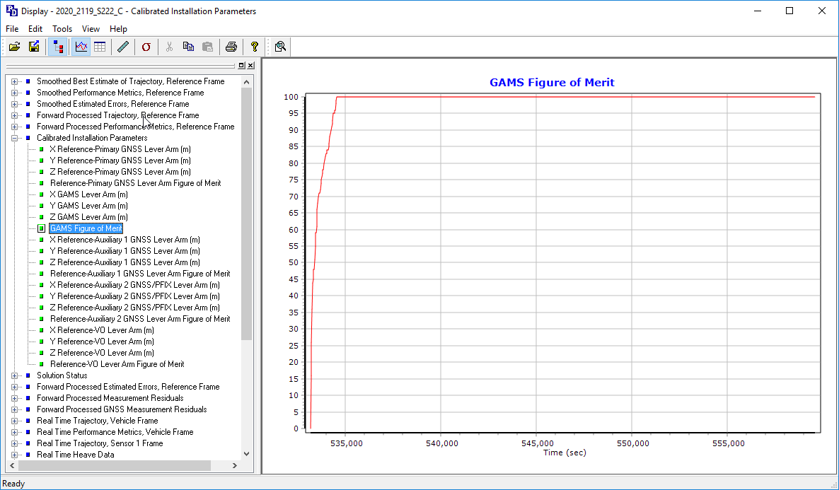

If it is, select the X GAMS Lever Arm, Zoom in on the last section of the chart on the right. This ending value is the calibrated value for X. Write down the values for X, Y, and Z.

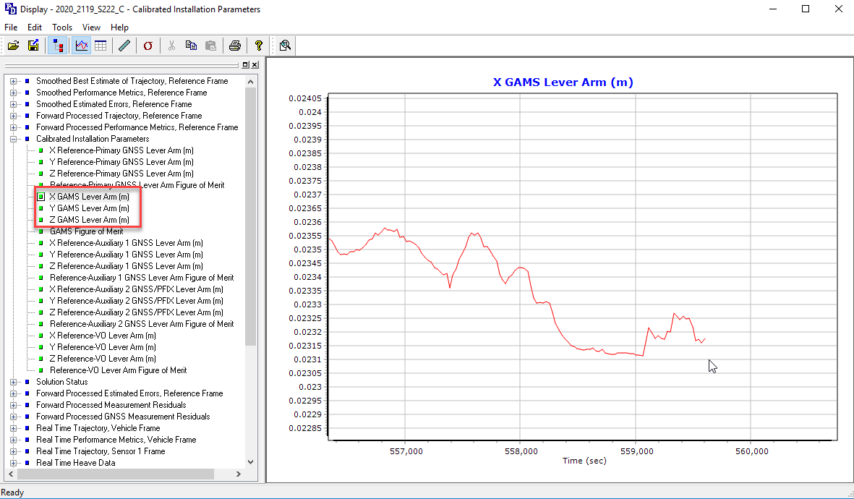

After you have your values for X, Y, and Z, go back to the Project settings and enter these values into the GMAS Baseline Vector for each respective lever arm.

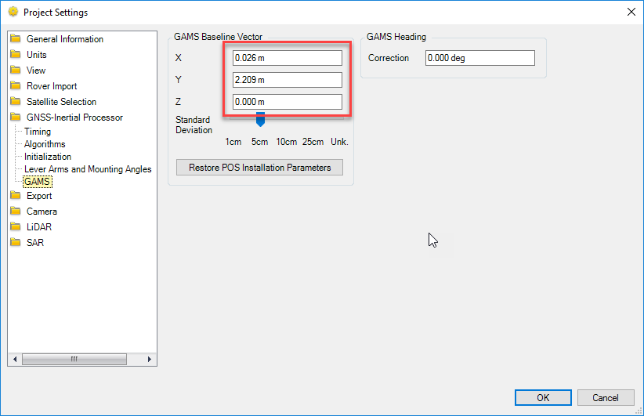

Now rerun GNSS-Inertial Processor.

Repeat these steps till the starting lever arm is close to the ending calibrated value.

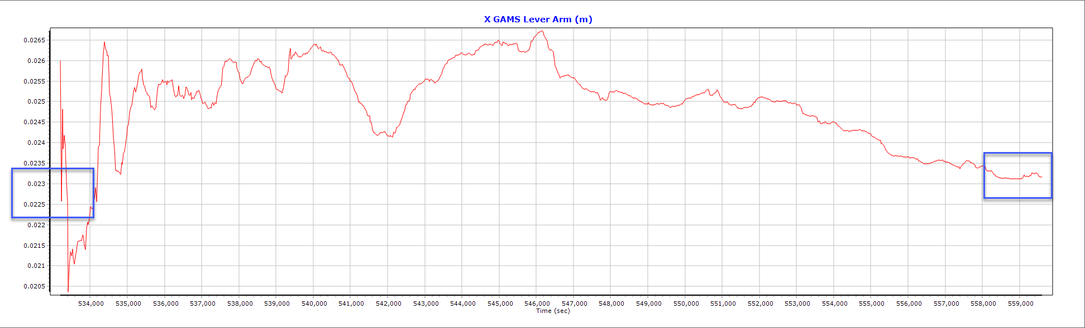

After finding your final calibrated values, Input these values into POS for the GAMS Baseline Vector.

# References

N/A